Name ________________________
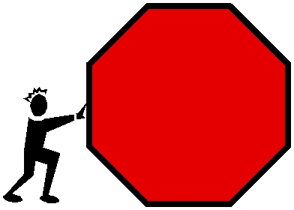
Educreations Geometry
Scavenger Hunt

Guidelines:
- Create an account:
- Click the setting button in the bottom right hand corner.
- Create an account. Use the class code your teacher provides.
- Select “student”
- Put your first and last name, your user ID will be your “AR” number. Make your password 1,2,3,4,5,6,7,8.
- You may work with a partner or on your own if you’d like.
- Find or create examples for the following geometry terms. Circle your choices on this sheet. Use your textbook as a resource. Be ready to identify a photographed example of the term and explain why it is a good example of the term.
- You may include a photograph or clip art from the web.
- You may speak into the microphone to record your explanation or type your explanation. Plan out what you will do and say on the back of this paper before you record.
- Do all of your geometry terms in one lesson. Record and pause as needed.
- Save your lesson with YOUR name(s) as the title.

You must have two items from List One:

Quadrilateral | Perpendicular Lines | Obtuse Angle
Straight Line | Parallel Lines | Right Angle
Semicircle | Rectangle | Irregular polygon
Vertex | Acute Angle | Square

You must have two items from List Two:

Regular octagon | Regular pentagon
Regular trapezoid | Regular decagon
Regular rhombus | Regular parallelogram
Trapezoid | Pentagon

You must have two items from List Three:

Right Triangle
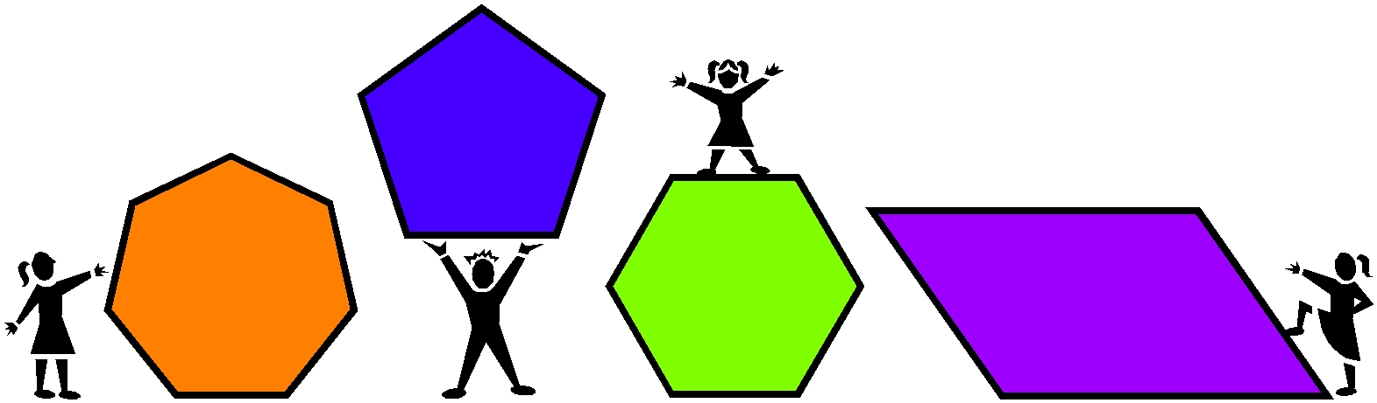
Acute Triangle
Equilateral Triangle
Isosceles Triangle
Scalene Triangle

Name________________________ Geometry Scavenger Hunt Project Scoring Rubric

Criteria | Excellent-4 | Good-3 | Adequate- | Needs | Total
 |  |  | 2 | Improvement-1 | Points
Presentation | Presentation is | Presentation | Presentation | Appears messy and
 | well designed, | is neat or | is not fully labeled. | “thrown together”
 | neat, and labeled | labeled |  | in a hurry. No
 | appropriately. | appropriately. |  | labels included.
Content | Project contains 6 | Project | Project | Project contains 0-
From | items from List 1 | contains 4-5 | contains 2-3 | 1items from List 1. | X2
List 1 |  | items from | items from
 |  | List 1. | List 1.
Content | Project contains 6 | Project | Project | Project contains 0-
From List 2 | items from List 2. | contains 4-5 | contains 2-3 | 1items from List 2. | X2
 |  | items from | items from
 |  | List 2. | List 2.
 |  |  |  | TOTAL | /18

Final Grade: ____ points =
